**Software Testing - Team C   
(Achim Baumgaertner, Kevin Luu, Nicole Spiegel)**

1. **Sprints**
   1. **Number of sprints planned**
   2. sprints planned
   3. **Total number of story points assigned**

62 story points assigned

* 1. **Average story points per team member**

20.5 (20-21) per member (One story point equals 1 hour)

**Add some screenshots of your storyboard or sprint view from the Github Project.**

**User Storys for features with PlanningPoker**

* As a user I want to be able to edit my tasks so that I don’t have to delete the old one and create a new one in case of a change or mistake.
* As a user I want to have a working status indicator so that I know which tasks are checked/done or unchecked/not done.
* As a user I want to be able to sort my tasks by date or by status, so that it’s more convenient for me to find a task.
* As a user I want to have a deletion popup before I delete a task so that I don’t accidentally delete a task I didn’t intend to delete.
* As a user I want to be able to export my table so that I can make usage of the exported data, for example saving the table for logging or printing the table to have a physical copy.

**Sprint 1**

**Sprint 2**

**Sprint 3**

This is mainly for finishing Sprint 2 and completing as far as we come with testing in a reasonable time

**Sprint 3.1**

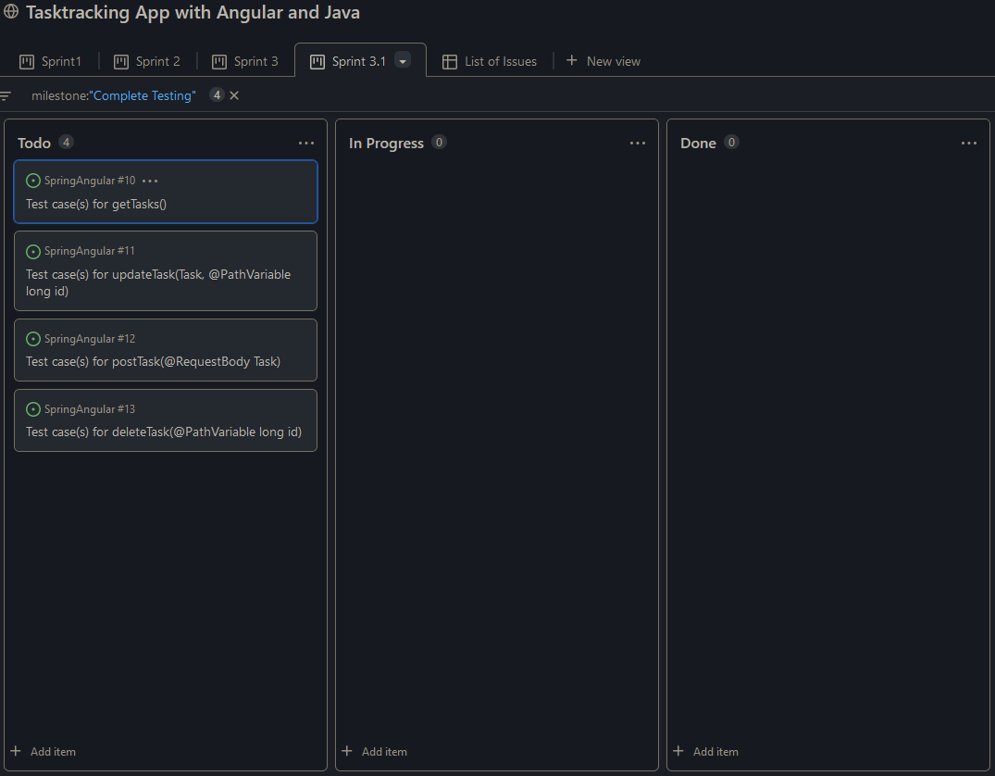

1. **Scrum**
   1. **Number of scrums as of November 4th**

8 Scrum meetings

(10/18, 10/20, 10/24, 10/25, 10/27, 11/1, 11/3, 11/4)

* 1. **Average attendance in scrum**

Everyone has attended all times as of now (3 people)

1. **Project Progress**
   1. **Number of story points completed by the team**

5 completed

* 1. **Average story points completed by the team members**

1.7 (1-2) per member